Official Adoption Agreement

For the Direct Support of:

Friends of Hope
India

Hope for a future. Hope for an education. Hope for a life filled with the Love of God. Friends of Hope is a non-profit organization based in the Midwest of the United States that supports compassionate ministries to the children in nations where poverty and destitute situations abound. Friends of Hope sponsors short-term mission trips that perform relief work through medical camps and prayer.

Partnering with Friends of Hope gives action to words by reaching out to the destitute children of the world. For many of them, Friends of Hope is the only difference between life and death. Not only does Friends of Hope clothe, feed, love and care for the children, but through shared partnerships of caring people, boys and girls receive hope in this life and the next.

For more information, please contact Pastor Tom Curry at: TCurry@fohglobal.org or fohglobal.org

Amount of support Pledged from our Family or Organization: $_________________
Our Gift will be sent: ( ) Once with this agreement ( ) At the end of one year
( )Semi-Annually ( ) Quarterly ( ) Monthly

_____________________________________________________
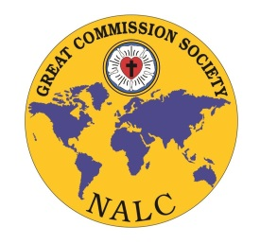
Congregation or Individual’s Name

_____________________________________________________
Address/ City/State/Zip

_____________________________________________________
Email Address

_____________________________________________________
Signature and Date

Great Commission Society of the NALC
Instructions for Official Adoption Agreement:

□ Please print three copies of this agreement and retain the first for your records

□ Please send the second copy and funds to:
Friends of Hope
2033 E Kitchel Rd.
Liberty, IN 47353

□ Please send the third copy to:
North American Lutheran Church
Missions Office
2299 Palmer Drive; Suite 220
New Brighton, MN 55112

Should you have any questions, please contact Jenny Brockman in the Missions Office at: 651-633-4260 or jbrockman@thenalc.org

