Official Adoption Agreement

For the Direct Support of:

Lutheran Church of South Sudan

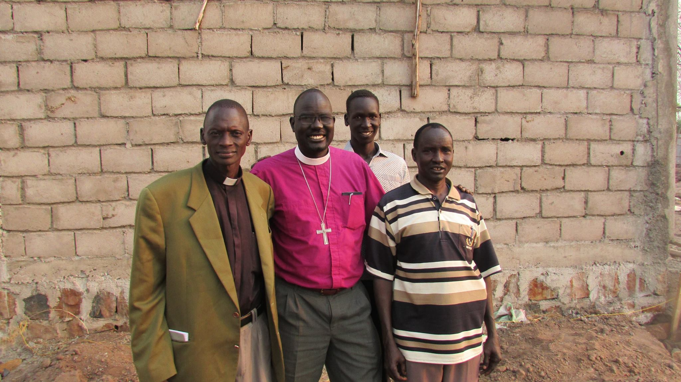
The community of South Sudanese refugees displaced by the civil war numbers in the millions. LCSS is currently expanding mission efforts in the refugee camps in Ethiopia and Kenya. Two needs are met by the LCSS’s Trinity Lutheran Seminary and College: 1.) Leadership for growing and new congregations among the refugees; 2.) Hope for education, training and a better life for refugees in and around the camps close by Gambella, Ethiopia. The immediate project goals are the creating of effective learning environments for students so that they can graduate, serve God, their families and their fellow refugees. We also seek the goal of a successful community celebration surrounding the graduation, ordination and sending of the next cohort of pastors to the mission field. Currently more than 1,000 students are enrolled in both the college and seminary programs.

For more information, please visit: www.lutherancss.org. Alternatively, please contact Pastor John Kline at: johnkline@ziondsm.org or Pastor Jordan Long at: manpign@gmail.com.

Amount of support Pledged from our Family or Organization: $_________________
Our Gift will be sent: ( ) Once with this agreement ( ) At the end of one year
( )Semi-Annually ( ) Quarterly ( ) Monthly

_____________________________________________________
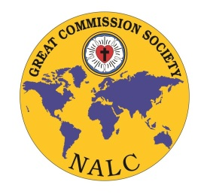
Congregation or Individual’s Name

_____________________________________________________
Address/ City/State/Zip

_____________________________________________________
Email Address

_____________________________________________________
Signature and Date

Great Commission Society of the NALC
Instructions for Official Adoption Agreement:

□ Please print three copies of this agreement and retain the first for your records

□ Please send the second copy and funds to:
Lutheran Church of South Sudan
c/o Lutheran Church of the Master
2617 S 114th St
Omaha, NE 68144

□ Please send the third copy to:
North American Lutheran Church
Missions Office
3500 Mill Run Dr.
Hilliard, OH 43026

Should you have any questions, please contact Jenny Brockman in the Missions Office at: 614.777.5709 or jbrockman@thenalc.org

