Official Adoption Agreement

For the Direct Support of:

Pastor James Puotyual
South Sudan
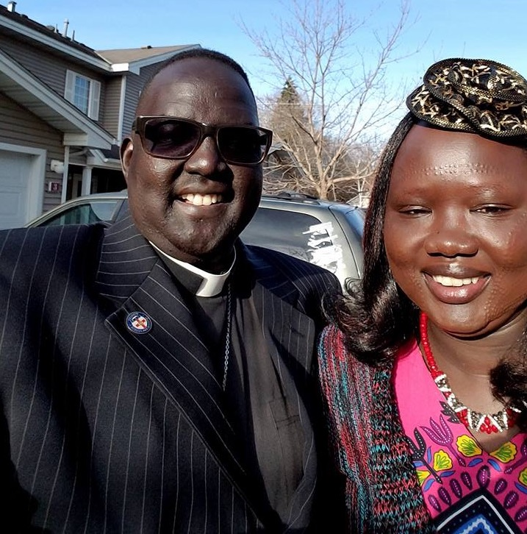
Pastor James Puotyual was born in the Upper Nile region of South Sudan. In 1985, due to civil war, he was forced to move to Ethiopia and Kenya, living for a few years in tents in United Nations refugee camps. While in the refugee camps, Pr. James married his wife, Nyandit Rika in 1987, after which a daughter was born and then died from malaria in 1990. In 1994, he along with his wife Nyandit and son, Jal, came to the United States. Once in the U.S., Pr. James worked at every opportunity to receive an education. James was ordained in 2015. He and Nyandit have two grown children, Jal Dobuol and Nyalat Dobuol. Today, because of continual civil wars in Sudan, there are over 500,000 refugees living near Gambella, Ethiopia. There is a constant need to show Christ’s love to these refugees. Pr. James is being sent to Gambella to serve that need. The primary work for Pr. James will be to provide sacramental worship and spiritual care for the Sudanese living in refugee camps in Ethiopia. He will work in partnership with the Lutheran Church of South Sudan and the Ethiopian Evangelical Church Mekane Yesus (EECMY).

For more information, please visit the Lutheran Church of South Sudan’s website: http://www.lutherancss.org or contact Pastor James at: jamespuot202@yahoo.com or Pastor Tim Lundeen at: prtim@gvtel.com

Amount of support Pledged from our Family or Organization: $_________________
Our Gift will be sent: ( ) Once with this agreement ( ) At the end of one year
( )Semi-Annually ( ) Quarterly ( ) Monthly

_____________________________________________________
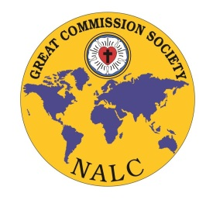
Congregation or Individual’s Name

_____________________________________________________
Address/ City/State/Zip

_____________________________________________________
Email Address

_____________________________________________________
Signature and Date

Great Commission Society of the NALC
Instructions for Official Adoption Agreement:

□ Please print three copies of this agreement and retain the first for your records

□ Please send the second copy and funds to:
Lutheran Church of South Sudan
c/o Lutheran Church of the Master
2617 S 114th St
Omaha, NE 68144

(Note in Memo Line – Pastor James Puotyual, Global Worker)

□ Please send the third copy to:
North American Lutheran Church
Mission Office
2299 Palmer Drive
New Brighton, MN 55112

Should you have any questions, please contact Jenny Brockman in the Missions Office at: 888-551-7254 or jbrockman@thenalc.org

