For the Direct Support of:

Grace Lutheran Church Advance, North Carolina

Grace Lutheran Church is a mission plant of Saint John’s Lutheran Church, Statesville, NC, having begun in January 2016 in Advance, NC. This congregation worships in the chapel of a local funeral home. Saint John’s helped to provide administrative and worship supplies, rent subsidies and transportation assistance in the past.

Grace currently has a part-time interim pastor and desires to call a permanent pastor in the near future. Bible studies and the development of lay leaders and parish administration of the mission fellowship continue. Grace is active in several local mission endeavors.

Grace received a NALC mission grant for 2016 and is in the process of applying for additional NALC mission support. The congregation purchased a tract of land in Clemmons, NC, in the summer of 2018 and would welcome support, both financial and volunteer help to clear the heavily wooded land in preparation for building.

Amount of support Pledged from our Family or Organization: $ Our Gift will be sent: ( ) Once with this agreement ( ) At the end of one year
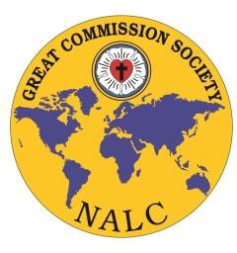
( ) Semi-Annually ( ) Quarterly ( ) Monthly

Congregation or Individual’s Name

Address/ City/State/Zip

Email Address

Signature and Date

Great Commission Society of the NALC Instructions for Official Adoption Agreement:

- Please print three copies of this agreement and retain the first for your records

- Please send the second copy and funds to: Grace Lutheran Church
PO Box 1735
Clemmons, NC 27012

- Please send the third copy to:
North American Lutheran Church Missions Office
2299 Palmer Dr, Suite 220
New Brighton, MN 55112

Should you have any questions, please contact Jenny Brockman in the Missions Office at: 614.777.5709 or jbrockman@thenalc.org

