NALC CONGREGATIONS
YOUR ASSISTANCE IS NEEDED.
This past year many places in our nation has been devastaded by natural disasters. The NALC Disaster Response has been actively providing assistance to these areas, which has left our warehouse in Ohio depleted of many of our stored items.
These items are:
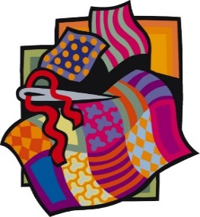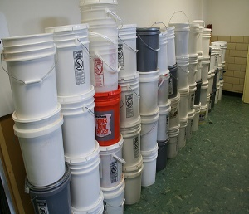
Quilts Flood buckets Gift Cards ANY size quilt or blanket including Five gallon buckets/lids, bleach Home Depot
fabric printed with religious, 1 gal bleach, 3-black trash bags Lowe’s
& military symbols! Cleaning liquid (Pine-Sol, Murphy’s, etc) Walmart
Scub brush, dust masks, gloves, rags/sponges Target

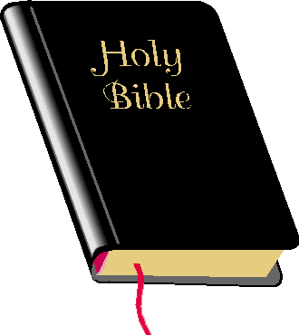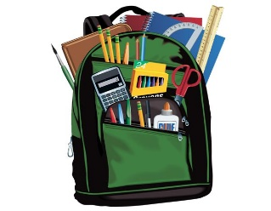
Health Kits Bibles School kits
One bath towel New or gently used One cloth bag or backpack
One wash cloth One blunt scissors
Two bars of soap, in original wrapping One ruler
One toothbrush One box of 16 or 24 crayons
One pack of dental floss One pencil sharpener
One tube of toothpaste (2 if sample size) Six new pencils
Deodorant One eraser Calculators for high school age
12 sheets of assorted construction paper
4 Notebooks of wide – or college-ruled paper, no loose-leaf paper
Please send these items to NALC Disaster Warehouse, 810 Main St., Caldwell, Ohio 43724. When shipping your donations to the warehouse, please add a note indicating from whom and where the support is coming. The families who receive your help really appreciate knowing you! Contact Mary Bates at 740‐509‐1132 or disasterresponse@thenalc.org for more information. Want to save on postage? These items can be purchased online and shipped directly to the warehouse. Thank you for your continued support and may the Lord continue to bless you as you serve those in need.
NALC Disaster Task Force

