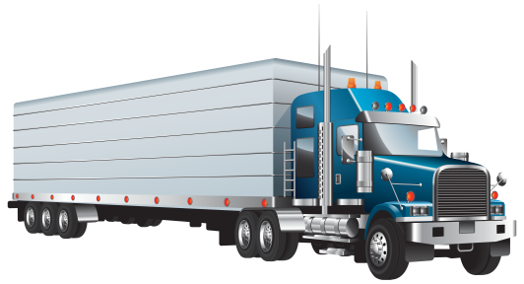
Stuff the TRUCK!
NALC Disaster
Response

NALC Disaster Response is able to send a Truck to your next scheduled event/metting to pick up donations from Mission Districts.
Please bring your collected items to the designated church: _____________________NAME of Host Church
at _______ADDRESS of Host Church_______________________
for pick up on _DATE___________________ from _10_________ to ___4pm_____________

Suggested Donations:

Bibles
Quilts & Blankets
Flood Buckets
School Kits
Healthcare Kits
Baby Care Kits
Gift Cards
Building Supplies
See Needs List for items in Kits

OR DELIVER TO:

NALC Disaster Warehouse
810 Main St.
Caldwell, Ohio 43724

MID-WEST Floods and Tornadoes:

NALC Disaster Response is collecting flood buckets, health kits, school kits, layettes, Bibles, and Lowes/Home Depot Gift Cards for the flooded areas in the Midwest. Thousands of families have been impacted by storms from Colorado to New Jersey by over 500 tornadoes. Three EF-3 tornadoes touched down in Western Ohio, killing one person and damaging hundreds of homes.
Flooding is occurring from South Dakota to Louisiana; from March storms in Nebraska that are now flooding the Arkansas and Mississippi Rivers.
If your congregation has any flood buckets and kits available, please contact Mary Bates at 740-509-1132 or by email at disasterresponse@thenalc.org to schedule pickup or delivery.
We will continue to support impacted congregations throughout the spring. Thank you for your prayers and support!
Mary Bates, Director
NALC Disaster Response
810 Main St.
Caldwell, Ohio 43724

