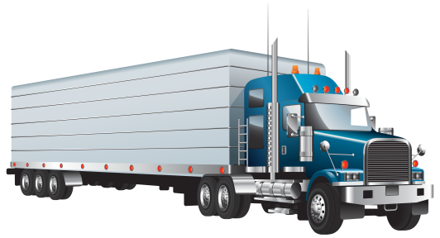
Stuff the TRUCK!
NALC Disaster
Response

NALC Disaster Response is able to send a Truck to your next scheduled event/metting to pick up donations from Mission Districts.
Please bring your collected items to the designated church: ______ First Evangelical Lutheran Church
at _______313 E. Fayette St., Manchester, Iowa 52057
for pick up on _September 14, 2019______ from _10am_________ to ___4pm_____________

Suggested Donations:

Bibles
Quilts & Blankets
Flood Buckets
School Kits
Healthcare Kits
Baby Care Kits
Gift Cards
Building Supplies
See Needs List for items in Kits

OR DELIVER TO:

NALC Disaster Warehouse
810 Main St.
Caldwell, Ohio 43724

MID-WEST Floods and Tornadoes:

NALC Disaster Response is collecting flood buckets, health kits, school kits, layettes, Bibles, and Lowes/Home Depot Gift Cards for the flooded areas in the Midwest. Thousands of families have been impacted by storms from Colorado to New Jersey by over 500 tornadoes. Three EF-3 tornadoes touched down in Western Ohio, killing one person and damaging hundreds of homes.
Flooding has occurred from South Dakota to Louisiana; from March storms in Nebraska that are now flooding the Arkansas and Mississippi Rivers.
If your congregation has any flood buckets and kits available, please contact Mary Bates at 740-509-1132 or by email at disasterresponse@thenalc.org to “Stuff the Truck” at the Iowa Mission District Convocation.
We will continue to support impacted congregations throughout the spring. Thank you for your prayers and support!
Mary Bates, Director
NALC Disaster Response
810 Main St.
Caldwell, Ohio 43724

