CONGREGATIONAL PROFILE | 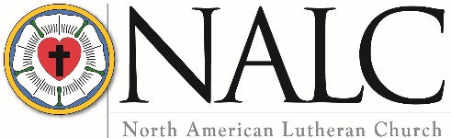
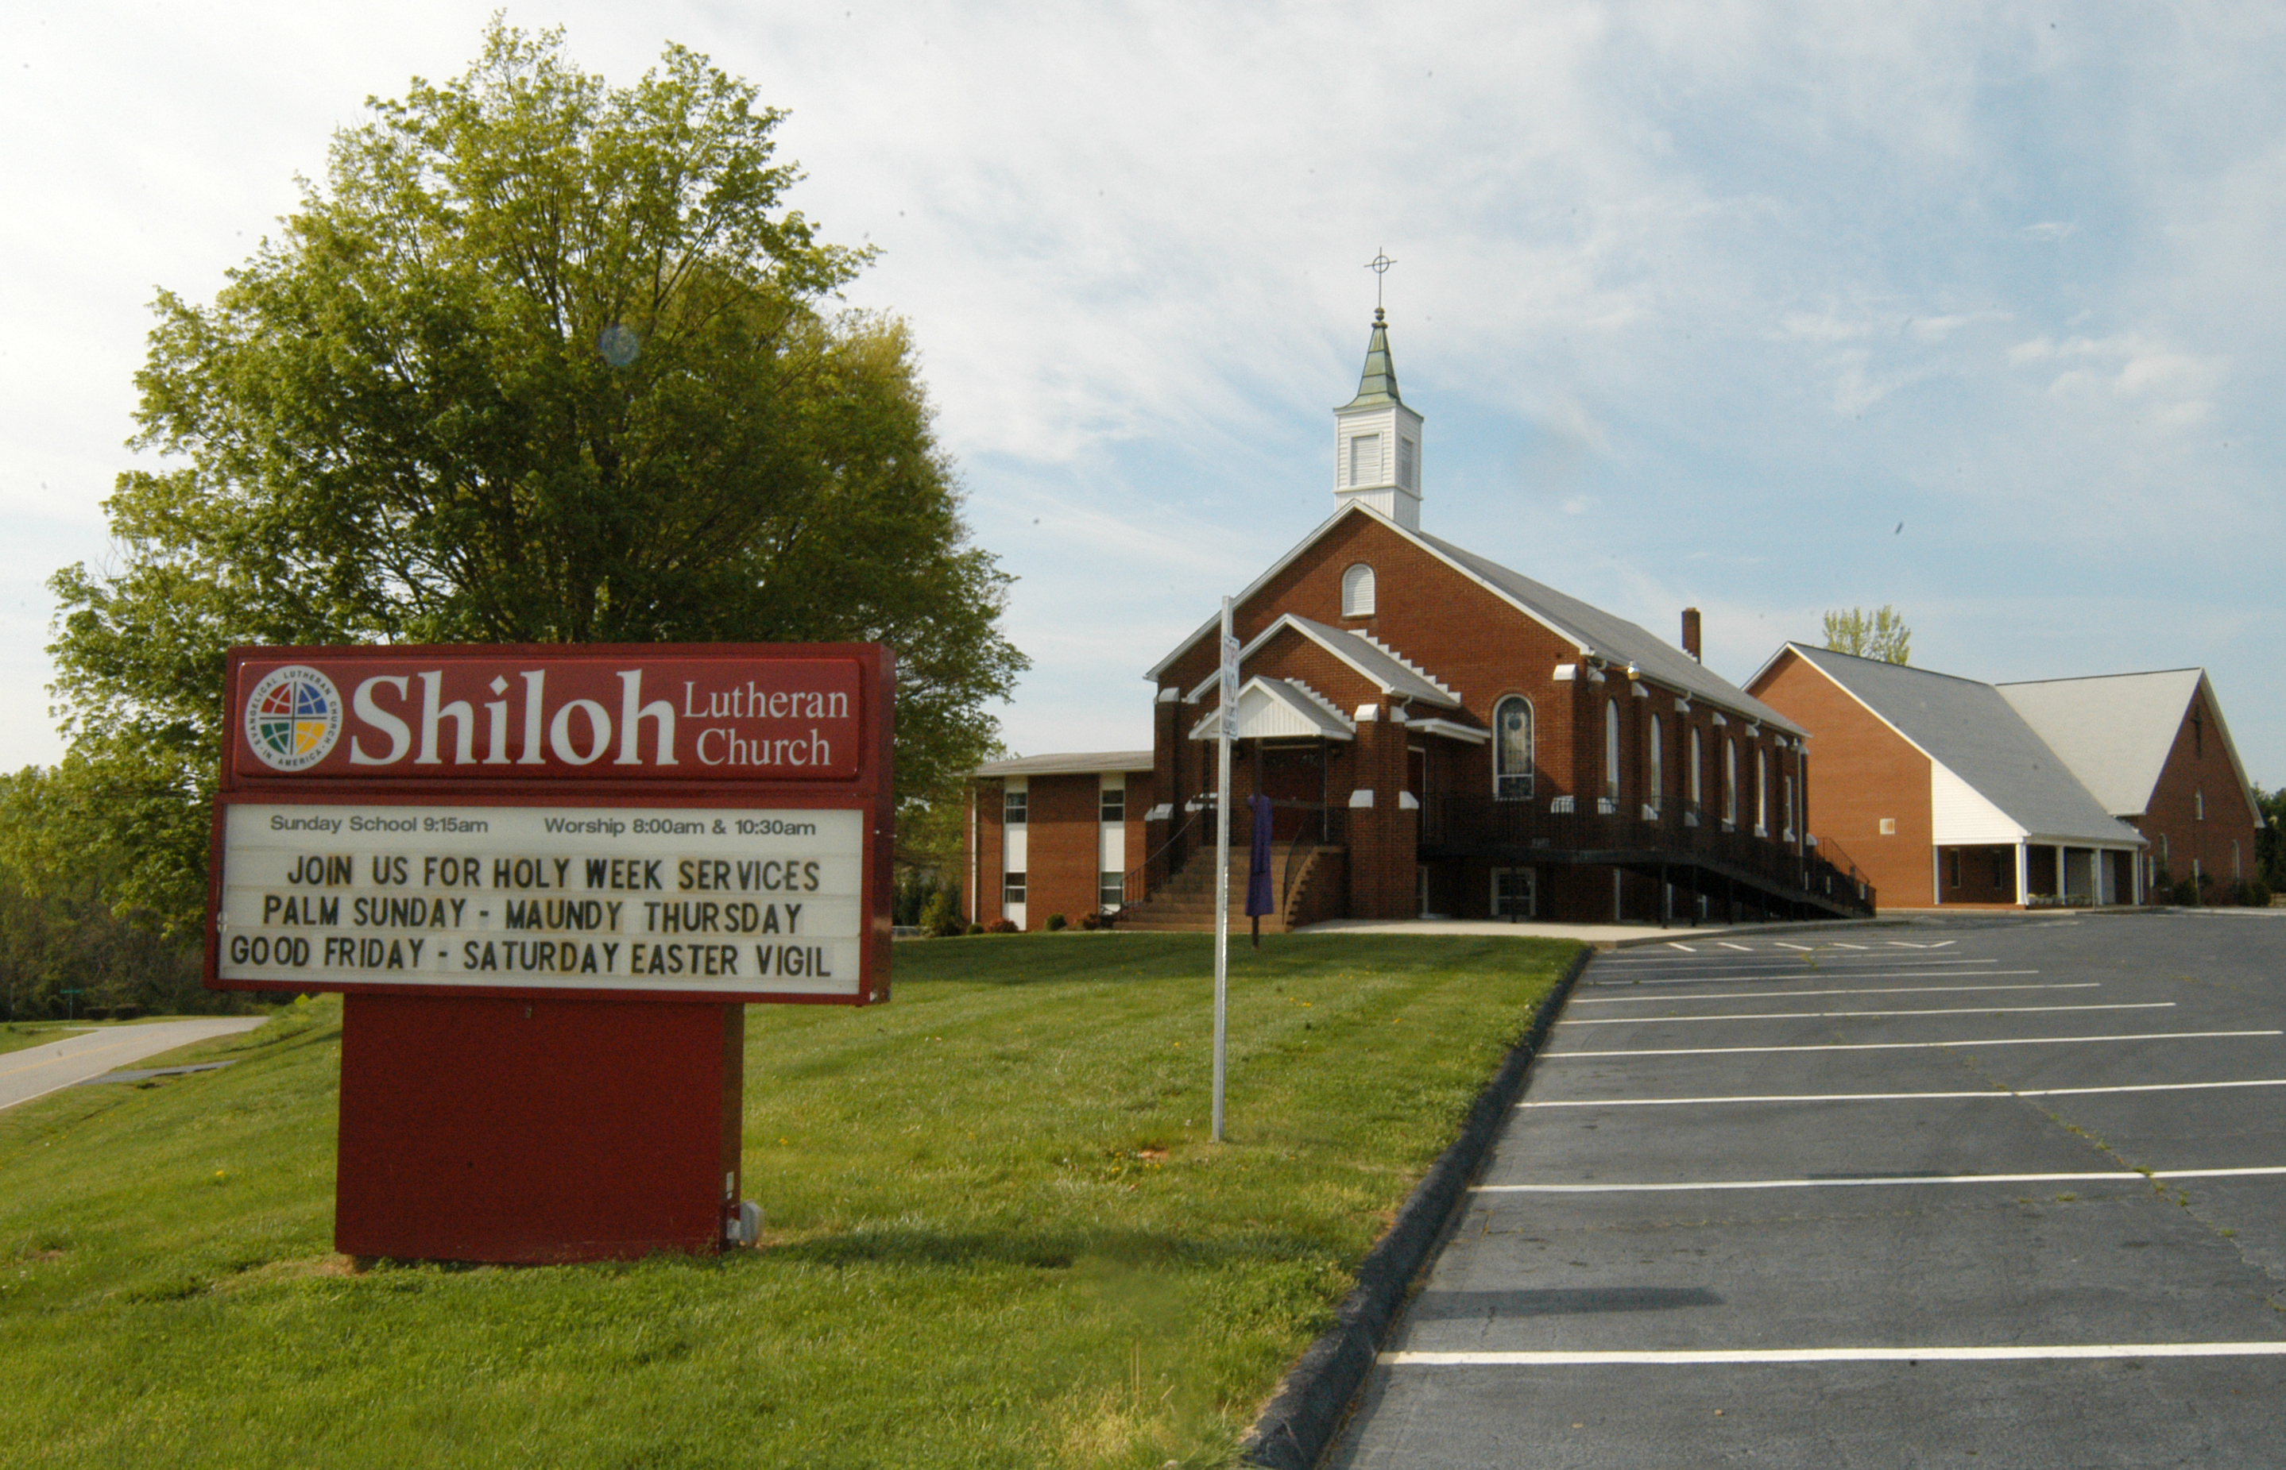
Congregation Name and Location

Name Shiloh Lutheran Church
Mailing address 1011 Shiloh Church Rd.
City Hickory State/Province NC Zip/Postal Code 28601
Telephone 828-495-7462 Fax N/A
Email address shilohlc@embarqmail.com
Congregation website http://www.shilohlutheranchurch.org/
Seeking ☒ Full-time pastor ☐ Part-time pastor ☐ Either full-time or part-time
Call will be for ☒ Solo pastor ☐ Senior pastor ☐ Associate pastor

Congregational President or Vice President

Name Helen Bowman Title President
Mailing address 257 Landis Lane
City Taylorsville State/Province NC Zip/Postal Code 28681
Home phone 828-495-7875 Cell phone 828-308-3393
Email address

Call Committee Chair

Name Nancy Bowman
Mailing address 598 Bowman Court
City Taylorsville State/Province NC Zip/Postal Code 28681
Home phone 828-495-8615 Cell phone 828-381-2637 PREFERRED #
Email address nanabx3@centurylink.net

Congregational Demographics

Number of paid staff (full- or part-time): Clergy 1 Lay professionals 3* Secretarial 1**
*Organist; Cleaning; Lawn Care **Part-time

Average worship attendance 52 Average Sunday school attendance 20

Indicate the type of community in which your congregation is located (is it small town, small city, suburban, large city, farming, industrial, etc.).
Rural – combination of suburban and farming
The church is located in the Bethlehem Community of Alexander County, NC but is generally considered a suburb of Hickory, NC with pockets of generational farming.

Established in 1886, we are located in the western portion of North Carolina in the foothills of the Blue Ridge Mountains, a few miles from Hickory, approximately 50 miles northwest of Charlotte, 80 miles east of Asheville, and 35 miles from the Blue Ridge Parkway.

Describe the congregation’s ethnic composition and age distribution.
The congregation is Caucasian.
Ages:
0-12 3
12-20 1
21-40 3
41-65 20
66-90 42

Does the congregation have a clear vision for mission — a clear and shared understanding of where God is leading you? If so, state it as succinctly as possible.
Yes. The congregation is very mission-minded locally, nationally, and globally.
Shiloh’s Mission Statement: The mission purpose of Shiloh as a family of God is to witness to the Good News of Jesus Christ through word and deed.

What are the primary goals of your congregation?
To fulfil God’s mission for all His people and to minister to the community – near and far.

Describe your congregation’s worship practice (liturgy, hymns, vestments, music, hymnals, and frequency of Holy Communion).
We enjoy varied Traditional worship with liturgy from Lutheran Book of Worship, With One Voice and This Far by Faith supplemented with worship resources including SOLA SOWeR.

Bulletins include the full liturgy and hymns (only Sermon and Prayers of the Church not printed).
LBW and WOV hymnals and ECS Bibles are in the pews and the Choir has TTF and other hymn resources.

Holy Communion is celebrated on the 1st and 3rd Sundays and on Festivals.

The congregation is very adaptable to changes in the liturgy and format of the worship service.

Describe your congregation’s Christian education ministry.
Children’s class
Adult class
Bible studies
VBS – two: one hosted by Shiloh and one in cooperation with 2 other churches in the community

Describe the congregation’s current activities for mission and outreach.

We sponsor multiple meals (Breakfast or Supper) to benefit others as well as participate in other outreach both from the congregation level and in concert with the community:

- Alexander County Special Olympic
- NALC Disaster Response Fund
- Hurricane Florence Disaster Relief
- Community Food Pantry
- Gordon Conwell Seminarian Sponsor
- CROP Walk for Hunger
- Samaritan’s Purse (OCC)
- Water International
- Alexander County Hospice
- Caring Hearts Pregnancy Center
- Alexander County Foster Children Angel Tree
- Back Pack for Kids – Weekend Meals Program
- Meals On Wheels

- Alexander County Soup Kitchen (with UMC)
- Community Hymn Sing – also host in rotation
- BENEVOLENCE – Envelopes (25% Beth. Elm. Sch.; 25% West Alex Middle Sch.; 50% NALC Fund for Theological Education
- Host Bethlehem Community Ministerial Assoc. Benevolence Office
- Participate in Ecumenical Community Easter Sunrise and Thanksgiving Eve Worship services
- Participate in “Bethlehem Star Lighting” and community Advent/Christmas event as well as “Drive-Thru Bethlehem” inter-active Christmas experience
- “Birthday Church” – Bethlehem Elementary School Benevolence Fund

When one of the largest congregations in our community suffered a fire, which destroyed their sanctuary and made their child care center un-inhabitable, our congregation reached out and helped them transport salvaged items to our Parish Hall where our congregation members joined the other congregation in cleaning the soot and water from items – until 1:30am on Sunday morning. We offered our facility as an alternate site for their child care center if they so desired and contributing to their fundraising.

The NALC is committed to moving away from an institutional understanding of the Church, to the biblical commission to be a community of followers of Jesus who focus on being disciples and making disciples. Which best describes your congregation’s understanding of this movement? [Type an X by the appropriate response]
Totally unaware
Have heard about it
Have been involved personally
X Some in the congregation are involved, some aren’t
Congregation understands, is on-board and involved

List the Top Five Things your congregations hopes for in its next Pastor
- Effective in Communication - teaching the Word of God and share the Gospel in clear and simple terms
- Good Spiritual Leader; motivational skills; and leads by example
- Active in Pastoral Care: visitation - all members, but especially the sick and home bound
- Friendly, Out-going and Approachable - a "people person" - enjoys working with people of all ages, especially the youth and others in the community
- Active Participant in all activities of Shiloh -including bible studies, group meeting, fundraisers, etc.
What were the three most significant events in your congregation’s history? Provide the years in which these events happened and why they are important to your congregation.
Change from LCA to ELCA – 1980’ish
Change from ELCA to NALC – 2010
Number attending and composition of congregation was greatly affected due to many young families attending a new non-denominational congregation – 2010-2011

Has your congregation participated in the Congregational Workshop Preparatory to the Call Process? [Type an X by the appropriate response]
X Yes No

What were the three most significant results of the workshop?

- Helped understand the process
- Gained new insights
- That the congregation needs to work together on the process

Describe the nature and extent of any significant current or recent conflict in the congregation. Is this conflict resolved, or ongoing? If resolved, how was it resolved?
N/A

How does your congregation handle conflict/tension? Which of the following do you think best describes your congregation? [Type an X by the appropriate response]
As a church, we respect and listen to each other and work things through without generating divisiveness.
As a church, we try to respect and listen to each other, but it is not uncommon for differences of opinion to be a problem and for some people to choose sides. Some have left our church because of conflict.
Conflict hurts our sense of unity, but we tend not to talk about it.
Painful experience with conflict has been present, but it has been worked through, and we have learned from the experience.
We have had some painful experiences with conflict, and they linger in the background.
Open conflict is present, and we need a minister who can help us deal with it.
X Other (describe)…...

We have experienced all these situations except “Open conflict is present, and we need a minister who can help us deal with it.”

What was the nature of the relationship between your last pastor and the congregation? Positive? Struggling? Cooperative? Tense?
Primarily Positive
As with any human interactions, there were the occasional instances where some thought a situation could/should have been handled in a more positive manner; but still, the overall relationship was good.

How did your council/congregational leaders work together with your last pastor? [Type an X by the appropriate response]
Leadership is shared, with shared decision-making
Pastor makes important decisions
X Council makes decisions with pastoral input
Council makes decisions without pastoral input

Is your pastor a member of council with: [Type an X by the appropriate response(s)]
Voice X Vote

Congregational finances

Total budget for last fiscal year: $109,192
Benevolence to the North American Lutheran Church: $1,050
Other benevolence: $600 to Gordon Conwell Seminarian
$325 to Carolinas Mission District
Non-budgeted Benevolence: $6,795
Total debt of the congregation: $0
Total savings, reserves, and endowments: $67,440

Compensation of Last Pastor

Salary: $ 40,485
Parsonage/housing allowance: $ {split made by pastor and his accountant from Salary $$}

Social security offset: $3,095 Pension: $3,800
Health Insurance: $9,812 {Medicare Supplements} Vacation: 4 weeks including 4 Sundays
Continuing education (time/funding): $665
Travel reimbursement: $3,000

Other: PACKAGE TOTAL: $60,857
When the Congregational Vacancy List is updated, a short paragraph (3-4 sentences) is included announcing each congregation’s ministry. If you wish, your call committee may compose that summary, realizing it may be edited/formatted as needed.

We strive to live out our Mission by engaging in many actions and activities to assist those in our community, country and the world. We also cooperate with other congregations and denominations in our community for mission and outreach. {See listing of this congregation’s current activities for mission and outreach.}

We look forward to a joint ministry with the Pastor God calls for us to be a good shepherd to His flock – young to old – and to walk with us as we proclaim God’s Word and Deed to all.

Completed by: Sharon Sharpe – Call Committee Secretary Date: November 24, 2019

