CONGREGATIONAL PROFILE | 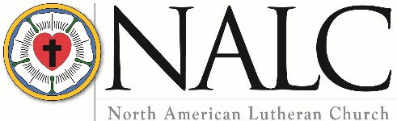

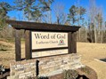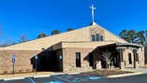

Congregation Name and Location

Name Word of God Lutheran Church
Mailing address 4486 East Highway 34
City Sharpsburg State/Province Georgia Zip/Postal Code 30277
Telephone 770-897-4508 Fax
Email address callteam@woglutheran.org
Congregation website www.woglutheran.org
Seeking ☒ Full-time pastor ☐ Part-time pastor ☐ Either full-time or part-time
Call will be for ☒ Solo pastor ☐ Senior pastor ☐ Associate pastor

Congregational President or Vice President

Name Geary Kent Title President
Mailing address 205 Woodland Drive

City Peachtree City State/Province Georgia Zip/Postal Code 30277
Home phone 770-487-7851 Cell phone 404-386-5285
Email address gkent205@bellsouth.net

Call Committee Chair

Name Emily Nadeau
Mailing address 101 Hidden Springs Lane

City Peachtree City State/Province Georgia Zip/Postal Code 30269
Home phone Cell phone 248-227-0963
Email address enadeau5@gmail.com

Congregational Demographics

Number of paid staff (full or part-time): Clergy: 1 Lay professionals: 4 Administrator: 1
Average worship attendance: 150 (to March 1); post March: 44 – 106 (depending on month)
Average Sunday school attendance: 50 (pre-Covid)

Indicate the type of community in which your congregation is located (is it a small town, small city, suburban, large city, farming, industrial, etc.).

Word of God is located in Coweta County, Georgia, north of the town of Sharpsburg and is strategically placed just outside and in-between the city limits of both Peachtree City, the largest city in Fayette County and Newnan, the largest city and county seat of Coweta County.

Peachtree City
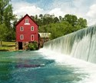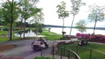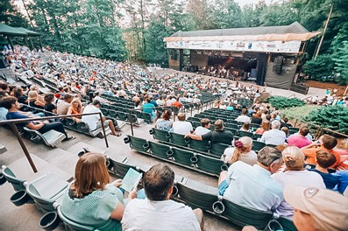

Peachtree City is an award-winning master planned community of over 36,000 residents located just south of Atlanta. Founded in 1959, the city is home to a diverse population and provides the best in residential housing, commercial areas, and community services to its citizens in what would be considered a middle to upper class area. A more complete description can be found at Peachtree City Information.

Newnan
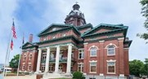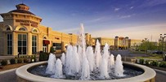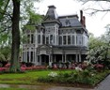

Newnan, with a population of nearly 47,000, is known as the City of Homes. There are six National Register Historic Districts containing some of Georgia's most beautiful homes and commercial buildings located here. Newnan was largely untouched by the Civil War due to its status as a hospital city for both Union and Confederate troops, and as a result still features much antebellum architecture. Celebrated architect Kennon Perry designed many of the town's 20th century homes. Several major movie studios are nearby, and Newnan is used frequently for location shots for film and television. A more complete description can be found at Newnan Information.

Sharpsburg
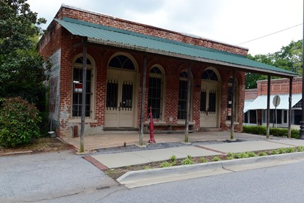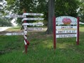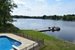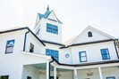

Sharpsburg is a town in Coweta County, Georgia, United States. It is part of the Atlanta metropolitan area. Its population was 341 at the 2010 census. Located in the rapidly developing corridor between Peachtree City and Newnan, it is an area of mostly farms and rural homes. A more complete description can be found at Sharpsburg Information.

Describe the congregation’s ethnic composition and age distribution.
We are located in an area that is predominately Caucasian and African-American. At present we are predominately Caucasian, but with a heart to reach out to more African-Americans and others. With ages ranging from birth to 90, the average age of the congregation at present is over 50, but we have several young families and we are in an area of enormous potential to reach many more young families.

Does the congregation have a clear vision for mission — a clear and shared understanding of where God is leading you? If so, state it as succinctly as possible.
With God’s help we are called to be a multi-generational traditional church, grounded in the Bible and focused on service in the community and mission outreach.

What are the primary goals of your congregation?
The three goals of Word of God are:

Grow in Faith • Build Disciples • Serve in Christ's Name
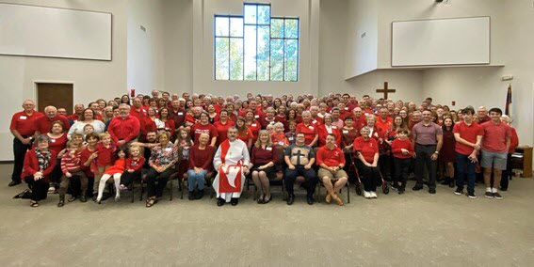
We are a congregation that is Christ centered, mission driven, traditionally grounded, and congregationally focused. Our congregation understands this as:
- Word of God Lutheran Church
This congregation is formed with its name at the Core.
- Great Commission Centered
Bible Studies, classes, Sunday School, Youth groups and activities have in mind intentional places to further develop a disciple’s journey toward becoming ever more like Christ.
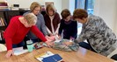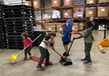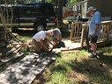
- Ministry Driven
There is an expectation of active members of this congregation being involved – as the Holy Spirit leads – in a life of ministry, reaching out with the love of Christ to others through the tangible ministries that are or will be established.
- Fostering Family
This congregation recognizes the gift of family.
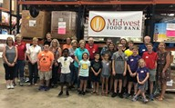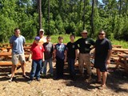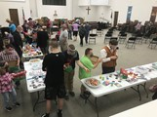
- Team Centered
This congregation is formed around the concept of Ministry Teams. These teams are made up of individuals and groups whose ministries align with their Ministry Team and for the purpose of being an organized ministry. These teams meet regularly to provide clear communication and coordination. They are made up of the active participating members of the congregation.
- Collaborative
This Core Value calls upon all at every level to first and foremost seek to hold all things in common and to be willing to always seek collaboration with decisions, attitudes and directions.
- Flexible
It is committed to the concept that we be able to adopt new ministries as they arise and allow old ministries to retire when their time is done.
- Stewards
This congregation is committed to tangible stewardship. It commits eleven percent of its receipts to benevolence. It encourages others through living a life of intentional stewardship, recognizing that such stewardship can never be measured in terms of money, but in terms of commitment to the cause of Jesus Christ.
- Interdependent
This congregation is deliberate with active participation of all its members in worship and worship leadership.
- Responsible
This congregation respects the call of each member who is called to the holy priesthood of all believers. Recognizing the variety of gifts and the varying level of ability, we hold each other to mutual accountability for the sake of the mission of Jesus Christ through Word of God.
Describe your congregation’s worship practice (liturgy, hymns, vestments, music, hymnals, and frequency of Holy Communion).

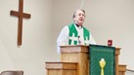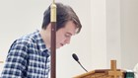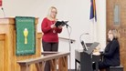

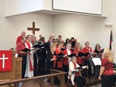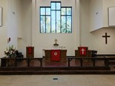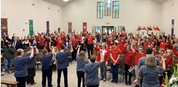

The objectives of the Worship and Music Ministry Team of Word of God are to make our worship grounded in biblical teaching, consistent with scripture, joyful, prayerful, meaningful, and reverent. We follow a liturgical worship service using the Lutheran Book of Worship and With One Voice hymnals and occasionally incorporate contemporary music along with our traditional hymns. The Worship and Music Ministry team meets with the Pastor every two months to plan the weekly Sunday services and the special services such as Lent and Advent, choose the appropriate hymns, and discuss any concerns surrounding worship. Adult and youth members of the congregation assist with the service by reading lessons, acting as worship assistants, and presenting a children’s sermon each week. Members also act as ushers, crucifers, acolytes, and communion host families. A volunteer writes the prayers that are offered during the service each week. Each of these service volunteers receive training prior to serving. Worship services are augmented using audio/video elements that rely on members to operate.

Word of God has continued to meet during the pandemic using the CDC guidelines of social distancing and wearing masks and hope to return to our regular worship practice as soon as possible. Prior to the pandemic, we offered communion each Sunday by intinction. With the Covid limitations, we are celebrating communion the second and fourth Sunday of each month using individual communion kits. Word of God follows the liturgical church calendar, and the Altar Guild volunteers set up the chancel area with the correct seasonal vestments which were beautifully made by a congregational member.

We are blessed to have a very talented pianist and choir director team. Prior to Covid, the adult choir practiced and presented special music several times a month, and a children’s choir (under separate direction) added their precious voices to our worship of God. A group of special needs young adults occasionally offer inspirational praise during worship. The pianist/choir director team vision for the future is to encourage its members to offer their musical talents in worship with individual solos, duets, trios and quartets. Additionally, we hope to have members who may not be part of the choir but have a talent with an instrument start to offer special music for preludes and/or communion. We would seek the participation and or prayerful support of the pastor in any of these areas.

Describe your congregation’s Christian education ministry.

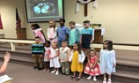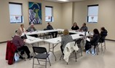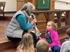

The purpose of Word of God Lutheran Church’s Christian Education Ministry is to equip followers and seekers of Jesus Christ to grow in the knowledge of The Word, share their faith, and act as disciples of Jesus Christ by offering opportunities both on Sunday and during the week for infants, children, youth and adults. This is pursued primarily by offering Sunday School during the school year to ages 2 years through adult. Currently, the following classes are offered:
Preschool (ages 2-4 years)
Early Elementary (ages Kindergarten-grade 2) using the Godly Play method
Late Elementary (grades 3-5)
Confirmation (grades 6-8)
High School (grades 9-12)
Differently Abled Adults (two classes)
Pathway2: Monthly Bible Study for differently abled/nonverbal adults, Intergenerational Events such as field trips, service projects and workshops, Vacation Bible School during the summer for differently abled adults. These classes/events are part of Fish Stix (a broad-based program for differently abled adults) which includes Sunday School, Vacation Bible School, Bible Study, Fish Stix Music Ministry/Outreach, and Fellowship.

Additional Christian Education opportunities include:
First Communion Class (grade 1 and up)
Annual Bible presentation to third grade children
Bible memorization annual recognition
Youth Fellowship on Sunday evenings
Youth Summer Mission Trip
Adult Weekday Bible Studies (1 during the daytime and 1 in the evening)

Describe the congregation’s current activities for mission and outreach.

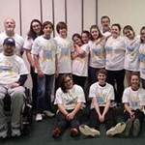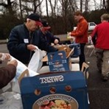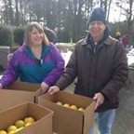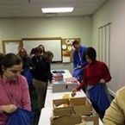
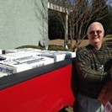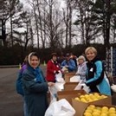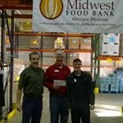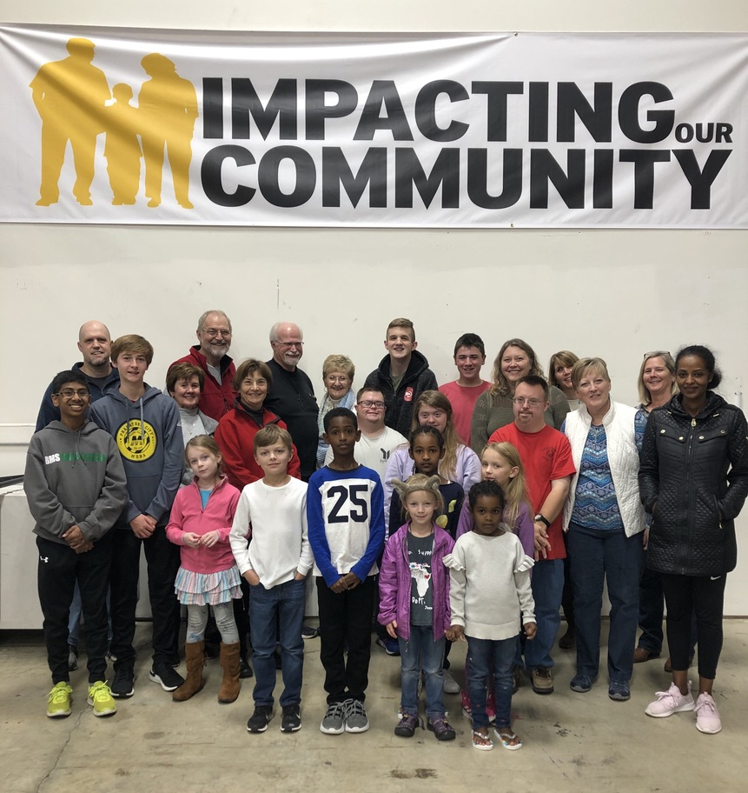

Word of God has a team of seven members who help ensure assistance is provided to those in need at local, national, and global areas. The church refers to this group as M.O.M., Mission Outreach Ministry. M.O.M. is provided with 11% of the congregational tithings, of which 1% is dedicated solely to mission trips. The other 10% is spread among 21 specific organizations along with a little set aside for disaster relief. The M.O.M team tries to ensure the receiving organizations are compliant with established legitimacy review organizations, have low administrative costs, and are spread evenly among local, national, and global areas. We have provided the list of the organizations we support below. We also provide a summary of these agencies on our website: www.woglutheran.org.

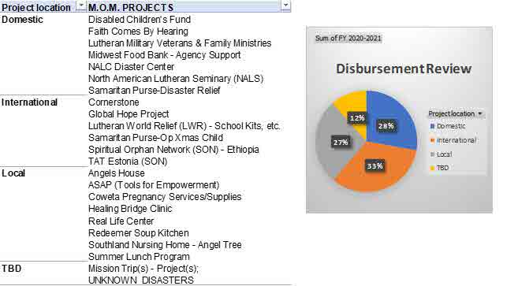

The NALC is committed to moving away from an institutional understanding of the Church, to the biblical commission to be a community of followers of Jesus who focus on being disciples and making disciples. Which best describes your congregation’s understanding of this movement? [Type an X by the appropriate response]
Totally unaware
X Have heard about it
Have been involved personally
Some in the congregation are involved, some aren’t
Congregation understands, is on-board and involved

List the Top Five Things your congregations hopes for in its next Pastor (from survey, 80 members responding)
- Joyous, friendly, approachable, hospitable, enthusiastic, energetic, inspiring goodwill, easy to talk to (Personality)
- Healthy leadership skills, willing to “lead from the front,” works well with Council and Staff, willing to try new things, good at leading congregation through change, works for consensus, creates unity
- Effective, engaging Biblical preacher and teacher
- Love of congregation – children, youth, adults, and senior adults
- Good mix of theology and practical ministry. We expect the candidate to be familiar with and in doctrinal agreement with the NALC booklet The Bible as the Word of God.
What were the three most significant events in your congregation’s history? Provide the years in which these events happened and why they are important to your congregation.
- Word of God Lutheran Church in Peachtree City, GA, chartered on October 31, 2010 with 169 charter members.
The decision to form a new church body followed changes in the historical theology and application of holy scripture by the ELCA and the local congregation. Members founded Word of God with the belief that they accept the canonical Scriptures of the Old and New Testaments as the inspired revealed Word of God, spoken in Law and Gospel as the final authority in all matters of their proclamation, faith, and life without change or reinterpretation by any church authority.
- Word of God Lutheran Church members approved the current constitution in October, 2015, establishing our congregation’s mission, goals, and structure. Out of this document the Core Values (as stated in the Goals question) of the congregation was also developed. These documents direct the actions of all members, committees, and boards.
- In October 2019 Word of God moved to its current campus in new facilities on 17 acres in Sharpsburg, Georgia. The impact on our ministry is significant and a wonderful blessing and gift from God to our congregation.

Has your congregation participated in the Congregational Workshop Preparatory to the Call Process? [Type an X by the appropriate response]
X Yes No

What were the three most significant results of the workshop?
- The congregation wants a pastor they can trust. Our pastor will be joyful, a “people person,” open minded, and approachable.
- Our pastor is able to share the gospel in a way that we can understand and relate to in our daily lives.
- Our pastor will agree with core NALC beliefs and doctrine.

Describe the nature and extent of any significant current or recent conflict in the congregation. Is this conflict resolved, or ongoing? If resolved, how was it resolved?
Contention between the previous pastor and the service committee, as well as several members over the last several years caused significant division within the congregation. The previous pastor resigned last June and almost all of the hurt feelings within the congregation have abated. Minimal loss of membership has occurred since then and several members have returned to active participation.

How does your congregation handle conflict/tension? Which of the following do you think best describes your congregation? [Type an X by the appropriate response]
As a church, we respect and listen to each other and work things through without generating divisiveness.
X As a church, we try to respect and listen to each other, but it is not uncommon for differences of opinion to be a problem and for some people to choose sides. Some have left our church because of conflict.
Conflict hurts our sense of unity, but we tend not to talk about it.
Painful experience with conflict has been present, but it has been worked through, and we have learned from the experience.
We have had some painful experiences with conflict, and they linger in the background.
Open conflict is present, and we need a minister who can help us deal with it.
Other (describe)…...

What was the nature of the relationship between your last pastor and the congregation? Positive? Struggling? Cooperative? Tense?
The initial relationship with the previous pastor was good. However, over the last several years, conflict arose between the pastor, the service committee, and several other members. In spite of private meetings, individual conversations, and intervention by NALC staff, an amicable resolution did not occur. The pastor subsequently resigned.

How did your council/congregational leaders work together with your last pastor? [Type an X by the appropriate response]
X Leadership is shared, with shared decision-making
Pastor makes important decisions
Council makes decisions with pastoral input
Council makes decisions without pastoral input

Is your pastor a member of council with: [Type an X by the appropriate response(s)]
Voice X Vote

Congregational finances
Total budget for last fiscal year: $ 310,000
Benevolence to the North American Lutheran Church: $ 6,000
Other benevolence: $ 39,582
Total debt of the congregation: $ 1,377,659
Total savings, reserves, and endowments: $ 166,910

Compensation of Last Pastor
Salary: $ 20,794
Parsonage/housing allowance: $ 36,000
Social security offset: $ 3,230
Pension: $ 12,000
Health Insurance: $ 7,200
Continuing education (time/funding): $ 1,200
Travel reimbursement: $ 6,900
Phone $ 1,520
Life Insurance $ 1,306
Vacation: 4 weeks

When the Congregational Vacancy List is updated, a short paragraph (3-4 sentences) is included announcing each congregation’s ministry. If you wish, your call committee may compose that summary, realizing it may be edited/formatted as needed.

If you are a pastor –
- committed to the “heart and soul” of our beloved NALC,
- with a deep love for your Savior Jesus Christ and His Church,
- and a warm out-going love for the people of your congregation and the surrounding community,
- looking for an opportunity to lead a congregation in discipleship and multiplying The Kingdom,
- in an area that is both beautiful and full of potential for reaching new people,
- driven with energy and enthusiasm for full pastoral ministry in a vibrant congregation bursting with potential,
THEN pray for the Holy Spirit to help YOU DISERN if His Will is to call you here to Word of God Lutheran Church.

Video Link URL: https://youtu.be/iz8jE6FJCGI

Completed by: The Call Committee of Word of God Lutheran Church, Sharpsburg, Georgia
Emily Nadeau, Chair
Date: February 10, 2021

