CONGREGATIONAL PROFILE | 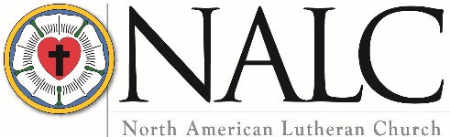

SAVE the document on your computer with your congregation’s name,
city and date completed as part of the file name.

EMAIL COMPLETED PROFILE to dwendel@thenalc.org.
Keep a copy for your records.

Congregation Name and Location

Name Saint James Lutheran Church
Mailing address 1942 Saint James Church Road
City Newton State/Province NC Zip/Postal Code 28658
Telephone 828-464-1953 Fax
Email address
Congregation website https://stjameslutherannewtonnc.com/
Seeking ☒ Full-time pastor ☐ Part-time pastor ☐ Either full-time or part-time
Call will be for ☒ Solo pastor ☐ Senior pastor ☐ Associate pastor

Congregational President or Vice President

Name Brent Stewart Title Congregational Council Vice-President
Mailing address 3932 Den Drive
City Hickory State/Province NC Zip/Postal Code 28602
Home phone 828-244-6170 Cell phone
Email address brent@stewart.tc

Call Committee Chair

Name Benjamin Stewart
Mailing address 3932 Den Drive
City Hickory State/Province NC Zip/Postal Code 28602
Home phone 828-244-6170 Cell phone 828-485-6129
Email address benjamin@stewart.tc
Congregational Demographics

Number of paid staff (full- or part-time): Clergy 1 Lay professionals 3 Secretarial 1

Average worship attendance 90 Average Sunday school attendance 30

Indicate the type of community in which your congregation is located (is it small town, small city, suburban, large city, farming, industrial, etc.).

St. James Lutheran Church is in Newton, NC. Newton is a small town located in the Piedmont of NC, with approximately 12,500 residents. Our congregants are predominantly rural and suburban.

Describe the congregation’s ethnic composition and age distribution.
The St. James Lutheran Church congregation is predominantly Caucasian, and its members are older.

Does the congregation have a clear vision for mission — a clear and shared understanding of where God is leading you? If so, state it as succinctly as possible.

Through a series of congregational workshops held by the Interim Ministry Transition Team, the following goals have been determined BY the congregational members. These goals are presented in order of priority as voiced by the members.

1. Evangelism

Equip our members so that when the opportunity arises, we will be able to share the gospel both inside and outside of our church family... To this end, we are committed to training members to be disciples who are able to make disciples.

2. Youth Ministries

To create new programs and expand existing programs to grow and nurture the faith life of our youth, and to engage additional young people in the working of the Kingdom of God.

3. Christian Education

Provide opportunities to learn and grow in the Christian faith using the Word of God as our foundation.

4. Adult Ministries

Provide strong, functioning small groups that allow deeper fellowship and increased participation throughout all age groups of the church.

5. Worship & Music

Provide regular opportunities for the congregation to worship and praise God through word, sacrament, and song in accordance with the liturgy of the NALC.

6. Community Outreach

Support, expand, and strengthen St. James’s presence and the sharing of God’s love and grace in our community.

What are the primary goals of your congregation?

1. Evangelism Goal: Equip our members so that when the opportunity arises, we will be able to share the gospel both inside and outside of our church family... To this end, we are committed to training members to be disciples who are able to make disciples.
Objective A – Provide opportunities for all members to be part of carrying out The Great Commission.
Objective B – Provide opportunities for bible study and for training of disciples on making disciples.

2. Youth Ministry Goal: To create new programs and expand existing programs to grow and nurture the faith life of our youth, and to engage additional young people in the working of the Kingdom of God.

Objective A – Provide opportunities for adults, acting as mentors, to connect to the youth.
Objective B – Continue to focus and emphasize youth representation and involvement on the committees of the church.
Objective C – Assure programs, ministry opportunities, and activities are present for “all youth” in our church.
Objective D – Continue to involve youth participation in worship services.

3. Christian Education Goal: Provide opportunities to learn and grow in the Christian faith using the Word of God as our foundation.

Objective A – Promote and provide Biblical learning and discipleship development through AM and PM Bible Studies.
Objective B – Utilize multiple teaching and learning methods, resources, and multi-media tools to nurture and grow a deeper understanding and relationship with Christ.

4. Adult Ministry Goal: Provide strong, functioning small groups that allow deeper fellowship and increased participation throughout all age groups of the church.

Objective A – Provide diverse opportunities for all adults to be involved in the church life, e.g. Bible study, social activities, women’s group, men’s group, Senior Citizens, etc.
Objective B – Ensure that all adults have a method of transportation to all church activities.
5. Worship & Music Goal: Provide regular opportunities for the congregation to worship and praise God through word, sacrament, and song in accordance with the liturgy of the NALC.

Objective A – Maintain a steadfast focus on giving praise, honor, and glory to God in response to the gift of forgiveness and salvation through Jesus the Christ.
Objective B -- Provide resources and means of recording & distributing the worship services to the home bound and the membership in general.
Objective C – Provide opportunities to investigate and consider alternate worship styles that are consistent with NALC accepted guidelines. 2/18/2020 Page 11

6. Community Outreach Goal: Support, expand, and strengthen St. James’s presence and the sharing of God’s love and grace in our community.

Objective A – Advertise and announce all church events, welcoming all in our community to participate.
Objective B – Support and nurture the Homeless Ministry in our community through financial and material gifts.
Objective C -- Continue and expand our involvement in the Eastern Catawba County Christian Ministry (ECCCM) through volunteering of time, sharing of physical gifts, and financial support.
Objective D – Open our doors and facilities to more community needs, events, and activities.

Describe your congregation’s worship practice (liturgy, hymns, vestments, music, hymnals, and frequency of Holy Communion).
Services are traditional in style. Holy Communion is every two weeks (1st and 3rd Sundays) and festival days. Hymns and liturgy come from the Lutheran Book of Worship (1978 edition). Occasionally With One Voice is used for hymns.

Describe your congregation’s Christian education ministry.
Our current Christian education ministry consists of the following:
Sunday School
Adult (2 classes)
Children
Weekly Bible Study
Youth Ministry
Choirs
Handbell
Adult
Children

Describe the congregation’s current activities for mission and outreach.

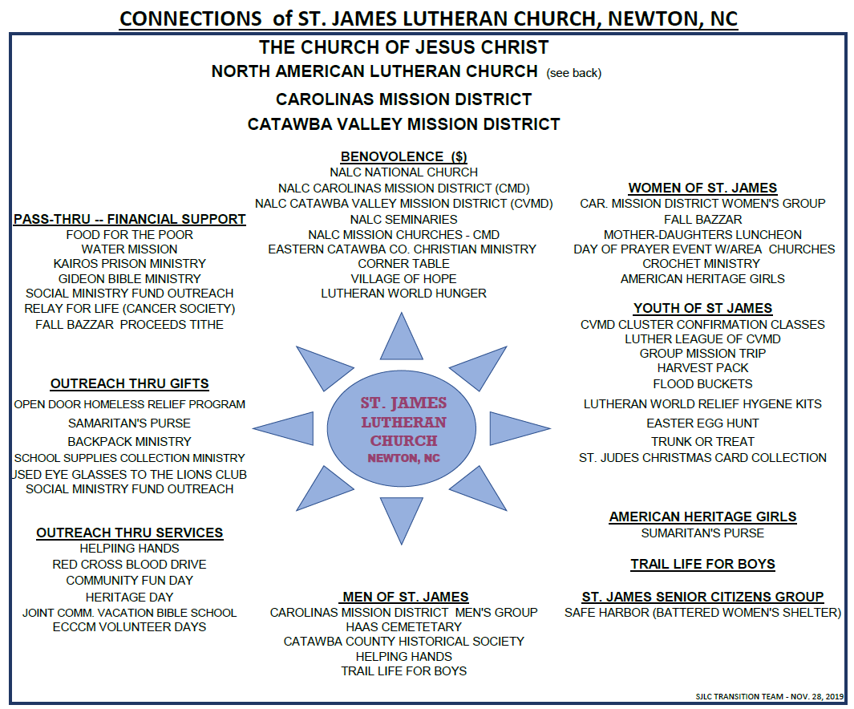

The NALC is committed to moving away from an institutional understanding of the Church, to the biblical commission to be a community of followers of Jesus who focus on being disciples and making disciples. Which best describes your congregation’s understanding of this movement? [Type an X by the appropriate response]
Totally unaware
Have heard about it
Have been involved personally
X Some in the congregation are involved, some aren’t
Congregation understands, is on-board and involved

List the Top Five Things your congregation hopes for in its next Pastor

- Preach and teach the Word of God biblically, faithfully, and dynamically. Engage the congregation on their level and provide useful life direction.
- Encourage biblical growth by building relationships with our youth as well as all other congregational generations.
- Must possess a strong focus on the visitation aspect of pastoral care. Willing to build lasting relationships with the congregants.
- Strong communication, team building, and organizational skills. In other words, a shepherd to lead the flock.
- An approachable individual who can offer applicable biblical counsel.

What were the three most significant events in your congregation’s history? Provide the years in which these events happened and why they are important to your congregation.
- The split from Haas Church in 1867 that led to the formation of St. James Lutheran Church.
- The decision to split from the ELCA in 2011. This event marked St. James commitment to the principles in the bible as understood by our congregation.
- The 150th Anniversary celebration. This event was important to the congregation as it allowed us to celebrate many years of service and ministry to the community.

Has your congregation participated in the Congregational Workshop Preparatory to the Call Process? [Type an X by the appropriate response]
Yes X No
St. James went through the intentional interim process in lieu of the actual congregational workshop. In addition, the transition team spent a year and a half gathering information and working through the processes required to prepare us for this process.

What were the three most significant results of the workshop?

- Mission Statement
- Vision Statement
- Congregational Goals and Plans

Describe the nature and extent of any significant current or recent conflict in the congregation. Is this conflict resolved, or ongoing? If resolved, how was it resolved?
No current/recent conflicts.

How does your congregation handle conflict/tension? Which of the following do you think best describes your congregation? [Type an X by the appropriate response]
As a church, we respect and listen to each other and work things through without generating divisiveness.
X As a church, we try to respect and listen to each other, but it is not uncommon for differences of opinion to be a problem and for some people to choose sides. Some have left our church because of conflict.
Conflict hurts our sense of unity, but we tend not to talk about it.
Painful experience with conflict has been present, but it has been worked through, and we have learned from the experience.
We have had some painful experiences with conflict, and they linger in the background.
Open conflict is present, and we need a minister who can help us deal with it.
Other (describe)…...

What was the nature of the relationship between your last pastor and the congregation? Positive? Struggling? Cooperative? Tense?
Uncomfortable, Stressful, and Distant. Our last pastor struggled to build the trust of the congregation due to communication challenges.

How did your council/congregational leaders work together with your last pastor? [Type an X by the appropriate response]
Leadership is shared, with shared decision-making
Pastor makes important decisions
X Council makes decisions with pastoral input
Council makes decisions without pastoral input

Is your pastor a member of council with: [Type an X by the appropriate response(s)]
X Voice Vote

Congregational finances

Total budget for last fiscal year: $ 217,162
Benevolence to the North American Lutheran Church: $ 1,000
Other benevolence: $ 19,000
Total debt of the congregation: $ 0
Total savings, reserves, and endowments: $ 66,000

Compensation of Last Pastor

Salary: $ 49,440 Parsonage/housing allowance: $ 3,708 (Equity Allow)
Social security offset: $ 5,150 (Self Employment) Pension: $ 3,708
Health Insurance: $ 12,000 Vacation: 2 weeks
Continuing education (time/funding): $1,000
Travel reimbursement: IRS Rate for Mileage
Other:

When the Congregational Vacancy List is updated, a short paragraph (3-4 sentences) is included announcing each congregation’s ministry. If you wish, your call committee may compose that summary, realizing it may be edited/formatted as needed.

As led and inspired by the Holy Spirit, we are Christ centered people with a rich heritage. We are committed to the obedience of Christ's Great Commission to spreading the Gospel, serving our neighbors, and furthering the Kingdom of God. This we do all to His Glory! AMEN

Consider filming a video to be included with your Congregational Profile on the NALC website Vacancy List. We invite your call committee to make a 3-5 minute video introducing prospective pastoral candidates to your context and congregation. The video can be informal, explaining what your congregation is seeking in a pastor and showing images of the members of your congregation and your worship environment. Here are some sample videos: Example One, Example Two. These samples were not produced by the NALC. They are both simply examples of the type of content you could include in a video.

Video Submission Instructions:
Upload your video to YouTube or Vimeo. (Here are instructions on how to upload to YouTube: wikihow.com/Upload-a-Video-to-YouTube.) Include a link to the video below. Make sure the link allows for public access to the video.
[video link]

Provide any other information about your congregation that may be helpful in the call process.
[enter text]

Completed by: Date:

SUBMISSION INSTRUCTIONS:

save a copy of this profile to your computer. Use “Save As” and specify document file name as:
Congregation name, City, Date

**Email a copy of the completed profile to the Assistant to the Bishop for Ministry, dwendel@thenalc.org.

Alternative submission method ONLY if you do not have email: Print and mail the complete profile to:

North American Lutheran Church
Attn: Pr. David Wendel
2299 Palmer Dr., Suite 220
New Brighton, MN 55112-2202

In addition, mail or email a copy of the completed profile to your mission district dean (can be found at thenalc.org/mission-districts/.

Should you have questions, call Pr. David Wendel, assistant to the bishop for ministry, at 719-650-8171 (cell).

Please keep a copy of this document for your records.

