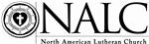
“DISCIPLES FOR LIFE”

LIFE CONFERENCE

JANUARY 28, 2021 - VIRTUAL

AGENDA
1:00 p.m. Participants are joining the Zoom

1:05 Welcome
Rebecka V.A. Frontz
Chairperson – NALC Life Ministries Team
1:10 Invocation
The Rev. Christopher Porter
Chaplain – NALC Life Conference

1:15 KEYNOTE ADDRESS
“Reconciling Relationships”
Deaconess Chrissie Gillet, PsyD
Director – Word of Hope
To be Disciples For Life – any life issue, including abortion – we need to be equipped to reconcile relationships. We value all human life as created, redeemed, and called people of God. Despite being saints, we are sinners living in a fallen world and desperately in need of reconciliation. Reconciliation involves an acknowledgement of the rupture, honesty about responsibility, repentance for wrongdoings, forgiveness of guilt, peace through love, and a desire for atonement. When it comes to life issues, this is a threefold process: 1) reconciliation with God, 2) reconciliation with my neighbor, and 3) reconciling my neighbor with God and other neighbors, all of which happens in and through Christ.

2:15 BREAK

2:30 PRESENTATION
“Invisible to Indispensable”
The Rev. Scott Licht
Executive Director of Finance & Operations - Lutherans For Life
Pastor - Shepherd of the Prairie Lutheran Church, Huxley, IA
God doesn’t make spare parts. He has a vocation for ALL people regardless of their age, stage,
ability, or life experience. Let’s look together at how indispensable EVERYONE is, including those
who may be “invisible” within our church and society at large.

3:15 PRESENTATION
“Developing and Living a Culture of Life”
The Rev. David McGettigan
Dean – Atlantic Mission Region
Areas of consideration in developing and nurturing a culture of life within the paradigm of
discipleship are explored within the local contexts of congregations and mission districts/regions.

4:00 WRAP-UP AND FINAL QUESTIONS
Rebecka V.A. Frontz
4:15 CLOSING PRAYER
The Rev. Christopher Porter

Learn more about NALC Life Ministries at www.thenalc.org/lifeministries

SPEAKER BIOGRAPHICAL INFORMATION
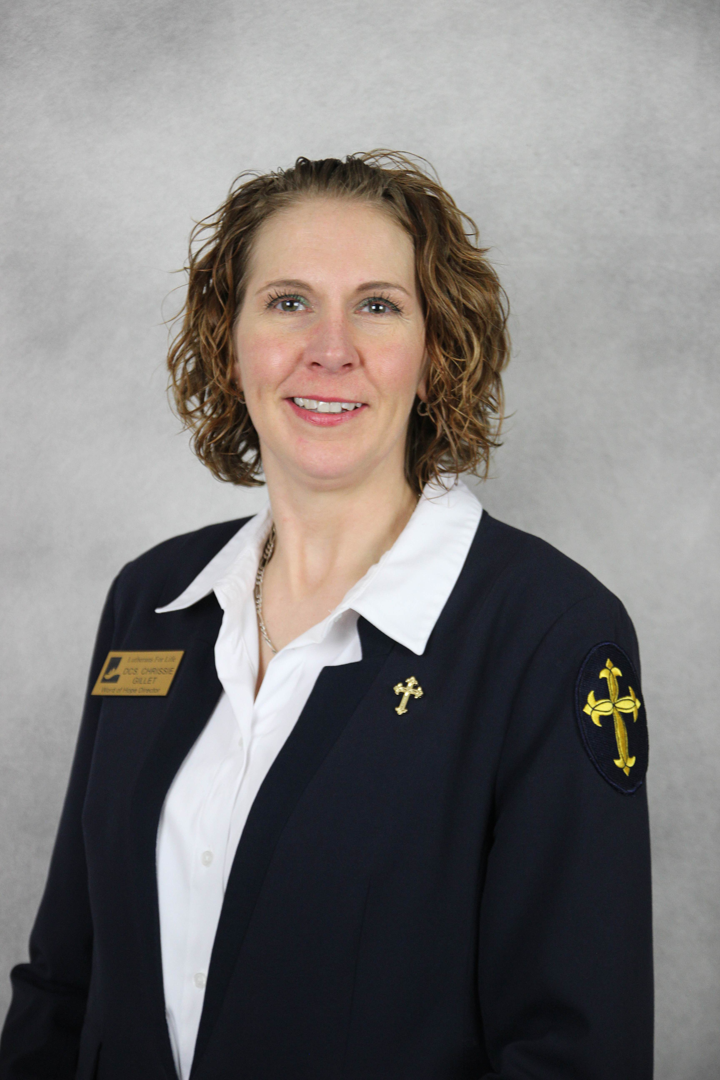

Chrissie Gillet
Deaconess Chrissie joined Lutherans For Life to serve as the Word of Hope Director in April of 2017. As a Veteran staff psychologist and certified deaconess, she has an acute understanding of both, the secular worldview and a Christ-centered identity. Her vocations as pastor’s wife and mother of seven further motivate her compassion for life.
Chrissie primarily answers the Word of Hope hotline calls and emails, during which she listens without personal judgment while also responding in Christian truth and love. She will go above and beyond to connect people with local services and natural supports but can offer diaconal counseling when appropriately necessary.
Beyond her typical hotline responsibilities, Chrissie writes articles, publicly speaks along with her service dog Phoebe, and leads Bible studies on a range of topics related to life issues.
~~~~~~~~~~~~~~~~~~~~~~~~~~~~~~~~~~~~~~~~~~~~~~~~~~~~~~~~~~~~~~~~~~
Scott Licht
Pastor Licht is the Executive Director of Finance & Operations at Lutherans For Life, Nevada, IA, and serves as Pastor of Shepherd of the Prairie Lutheran Church, Huxley, IA. He holds the following degrees: B.A. - Northwestern Lutheran College, Watertown, WI; MBA and MS Information Systems – Iowa State University, Ames, IA; MDiv Equivalent – Niagara Lutheran Theological Institute, Wilson, NY. Pastor Licht was ordained 2/23/2013 in the LCMC.
He is married to Sue, a music teacher for EK-2nd grade. Between the two, they have five daughters – two are Scott’s and three are Sue’s – ranging in age from 21 to 34 years old. They have three grandchildren – one who was called home as a result of miscarriage, one named Walter who is 2½ years old, and one named Arlo who is due to be born around March 23.
~~~~~~~~~~~~~~~~~~~~~~~~~~~~~~~~~~~~~~~~~~~~~~~~~~~~~~~~~~~~~~~~~~~~~~
David McGettigan
The Rev. David McGettigan serves as Dean of the Atlantic Mission Region.

NALC LIFE MINISTRIES TEAM

The Rev. Mark Chavez
General Secretary – NALC

The Rev. Dr. Dennis Di Mauro
Treasurer – Life Ministries Team

Mrs. Rebecka V.A. Frontz
Chairperson – Life Ministries Team

The Rev. Scott Licht
Executive Director of Finance and Operations - Lutherans For Life

The Rev. Melinda Jones
Executive Council – NALC

The Rev. Stevens Shipman
Assistant to the Dean – Atlantic Mission Region

Thank you for joining us today.

