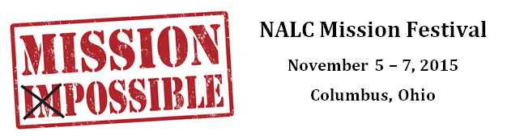

Scholarship Request

Name:

Address:

City/State or Province/Zip or Postal Code:

Phone:

Email:

Reason for request:

Signature:

Date:

*Please note that a request for a scholarship does not guarantee receipt of scholarship funds. All requests must be sent no later than September 1, 2015 to Jenny Brockman at jbrockman@thenalc.org.

